The Clarkston Community Center serves as a pillar of the Clarkston Community. Every week, hundreds of Clarkston citizens partake in the activities available at the community center, which range from the Clarkston Global Academy to the Digital Literacy Class to the Senior Refugee Program. I was given the opportunity to volunteer with Dare to be Aware, a program that strives to help refugee teens from places like South Africa, Afghanistan, Somalia, Kenya, and other countries better assimilate into American culture. Being a Minority Youth Violence Prevention program, Dare to be Aware teens are taught using the Positive Action curriculum to tackle diversity, bullying, goal-setting, employment, leadership, and healthy habits among other subjects. Teens in this program are exposed to new concepts weekly, allowing them to dabble in different subjects until they find their interests.
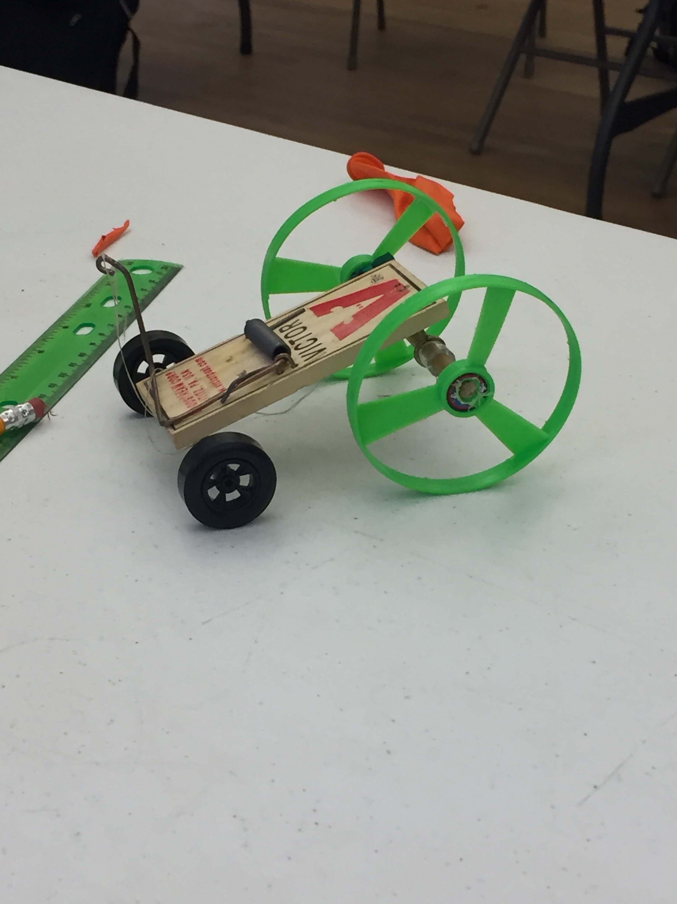o here)
The engineering program, for instance, allows students to construct their own mouse trap car and bottle rockets to compete against other schools at a local science competition sponsored by Georgia Tech. Besides being a fun activity, the mouse trap car exposes teens to scientific jargon and processes that are not always discussed in the classroom. Another activity the group does is the gardening program. The gardening program gives students the chance to learn more about biological processes by letting students observe the growth of plants. Aside from these skills, students are also guided through matters concerning college preparation.
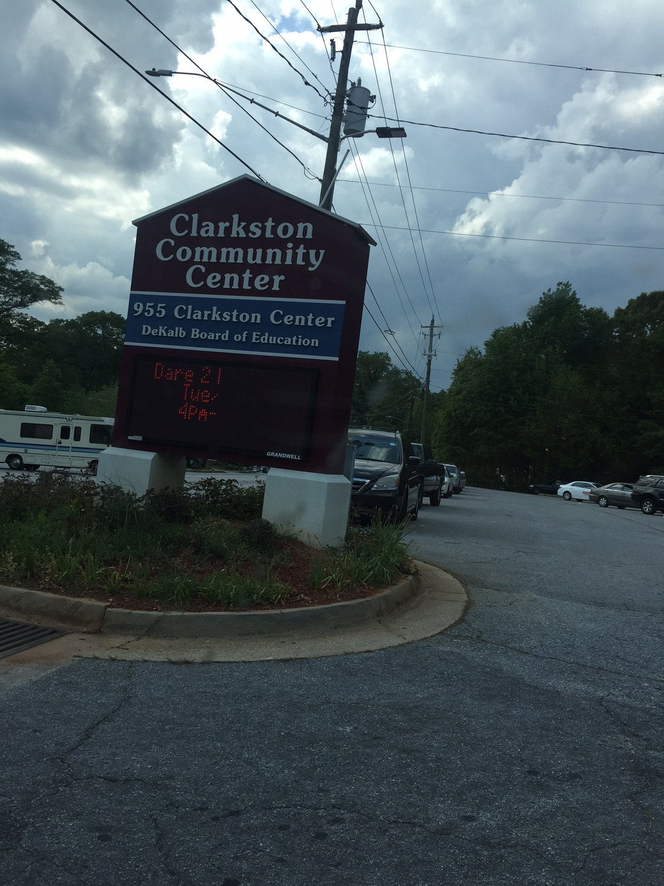
Dare to be Aware also encourages literacy among refugee teens by adding a book club component to the program. During the bi-weekly sessions, teens discuss the book (“Brother I’m Dying” by Edwidge Danticat) and create connections between the book’s protagonist and their own lives. Seven Stages, a small theater troupe located in Little Five Points, has teamed up with the students involved in Dare to be Aware to give students a chance to partake in the arts. Later this month, the teens will be participating in the Voices of Clarkston, a showcase that presents the artwork, poetry, spoken word, and plays derived from the creative minds of the citizens of Clarkston. The teens from Dare to be Aware plan to base their creative pieces from their book club book, “Brother I’m Dying.”
If you are interested in the Dare to be Aware program, the club meets Tuesday and Thursday at the Clarkston Community Center, which is located 3701 College Avenue, Clarkston, GA 30021. For more information, you can contact Justine Okello, the Director of Programs and Technology, at programs@clarkstoncommunitycenter.org. In addition, the program is open to youth ages 10-18 and is always seeking new volunteers. Happy volunteering!
Written By: Sydnie Cobb. (Georgia State University)

